Chapter 17:

Human Health & Environmental Risk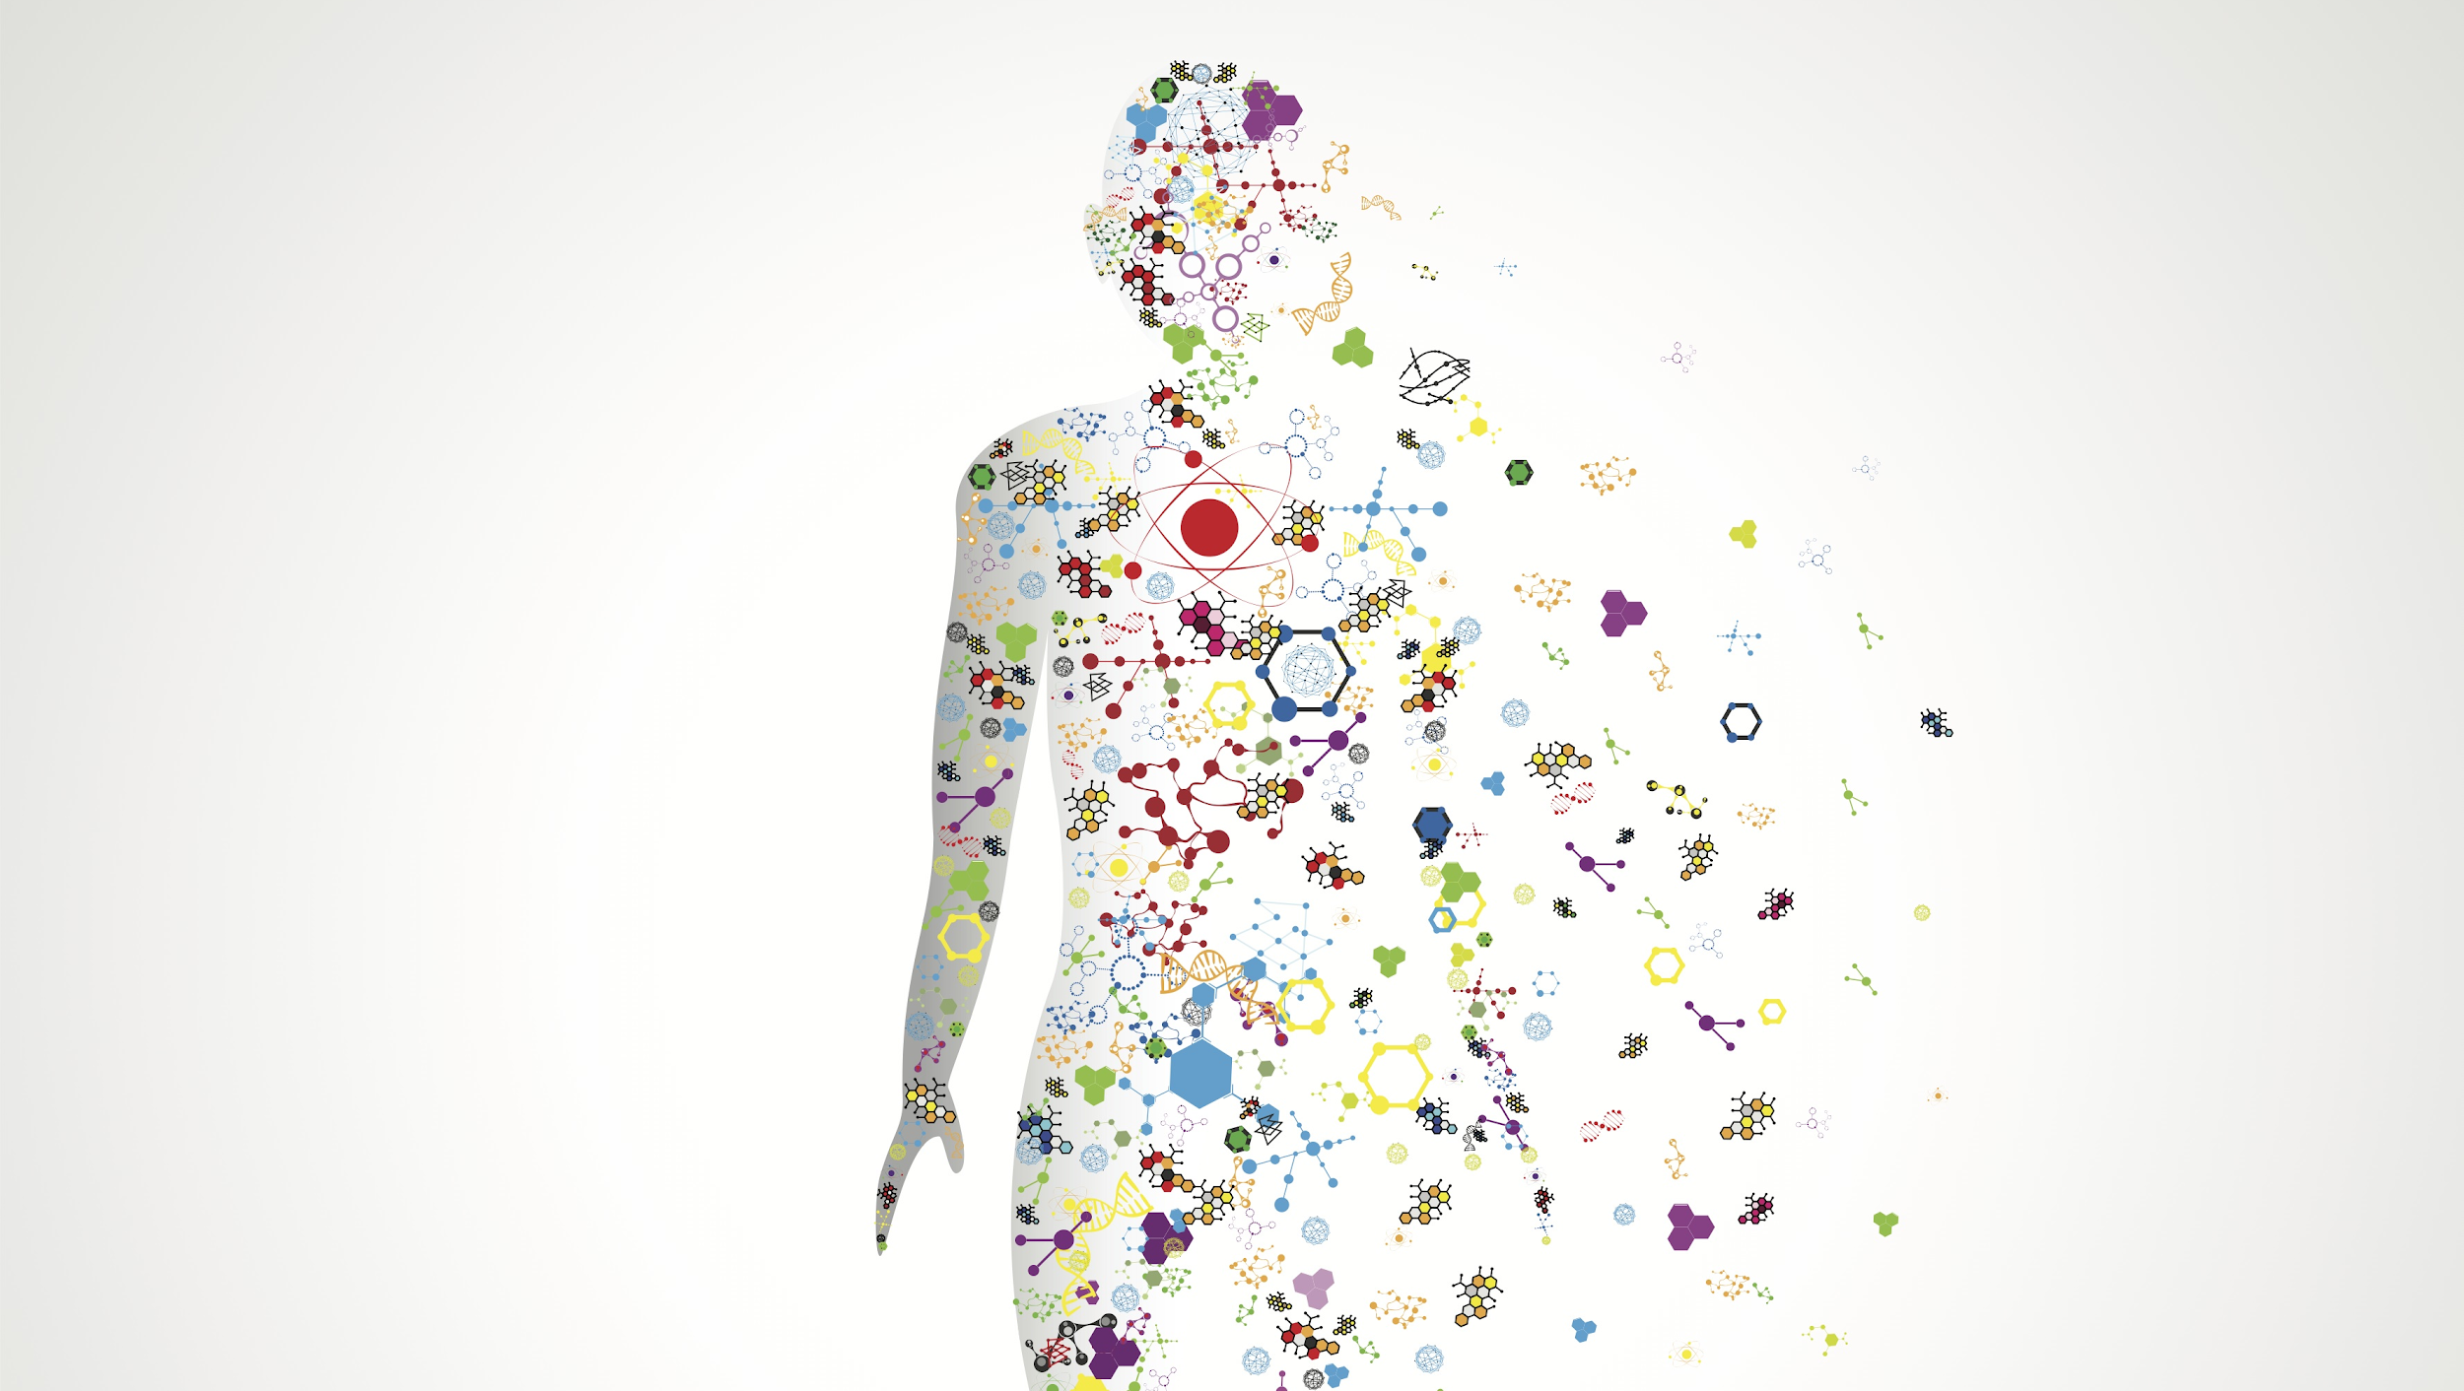

Can you….

1. Name and describe the common infectious diseases throughout history as well as recent emergent disease? Note: include symptoms and how the diseases spread
2. Explain the differences of risk factors in developed nations versus developing nations?
3. Compare and contrast the five categories of harmful chemicals?
   1. Neurotoxins
   2. Carcinogens
   3. Teratogens
   4. Allergens
   5. endocrine disruptors.
4. Explain the processes of dose-response studies and compare the different types?
5. Analyze an LD50 graph?
6. Explain the types of legislation involved with chemical management in the US?
7. Explain how chemicals are managed internationally?
8. Explain solubility, bioaccumulation, and biomagnification with chemicals in animals?